Consonance Rhyme

🔹 What is Consonance Rhyme
# Source: Chatgpt (GPT-4-turbo) at [8/1/2025]
⚠️ Like assonance and pararhyme, consonance rhyme is not a type of homograph, but a type of rhyme based on sound, not spelling or meaning.

✅ Definition of Consonance Rhyme
# Source: Chatgpt (GPT-4-turbo) at [8/1/2025]
Consonance rhyme is a poetic device in which the final consonant sounds (or any consonant sounds) are repeated, but the vowel sounds differ.
It creates a subtle, partial rhyme, typically at the end or middle of words.

🔊 Phonetic Pattern:
# Source: Chatgpt (GPT-4-turbo) at [8/1/2025]
Different vowel + Same consonant (especially final consonant sounds)

📝 Examples of Consonance Rhymes
# Source: Chatgpt (GPT-4-turbo) at [8/1/2025]
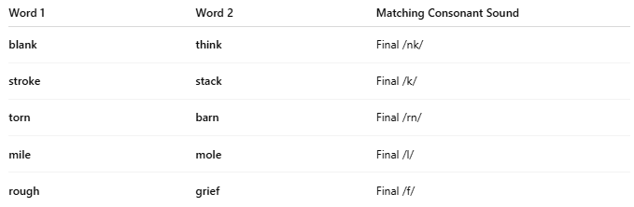
Word 1 | Word 2 | Matching Consonant Sound
blank | think | Final /nk/
stroke | stack | Final /k/
torn | barn | Final /rn/
mile | mole | Final /l/
rough | grief | Final /f/

🧠 Consonance vs Other Rhymes
# Source: Chatgpt (GPT-4-turbo) at [8/1/2025]
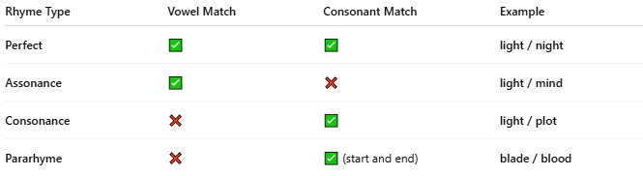
Rhyme Type | Vowel Match | Consonant Match | Example
Perfect | ✅ | ✅ | light / night
Assonance | ✅ | ❌ | light / mind
Consonance | ❌ | ✅ | light / plot
Pararhyme | ❌ | ✅ (start and end) | blade / blood

🔄 Consonance and Homographs
# Source: Chatgpt (GPT-4-turbo) at [8/1/2025]
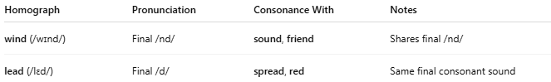
While not structurally related, some homographs may incidentally form consonance rhymes:

✅ Example: Homograph Pair with Consonance
# Source: Chatgpt (GPT-4-turbo) at [8/1/2025]
Homograph | Pronunciation | Consonance With | Notes
wind (/wɪnd/) | Final /nd/ | sound, friend | Shares final /nd/
lead (/lɛd/) | Final /d/ | spread, red | Same final consonant sound
Such examples arise more in poetic usage than in strict linguistic classification.

🧭 Summary Table
# Source: Chatgpt (GPT-4-turbo) at [8/1/2025]
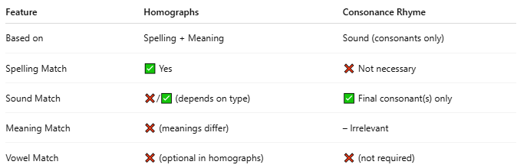
Feature | Homographs | Consonance Rhyme
Based on | Spelling + Meaning | Sound (consonants only)
Spelling Match | ✅ Yes | ❌ Not necessary
Sound Match | ❌/✅ (depends on type) | ✅ Final consonant(s) only
Meaning Match | ❌ (meanings differ) | – Irrelevant
Vowel Match | ❌ (optional in homographs) | ❌ (not required)

✅ Conclusion
# Source: Chatgpt (GPT-4-turbo) at [8/1/2025]
- Consonance rhyme is not a homograph type, but may involve words that are homographs by coincidence.
- Homographs can sometimes be used creatively in poetry to exploit consonance.

